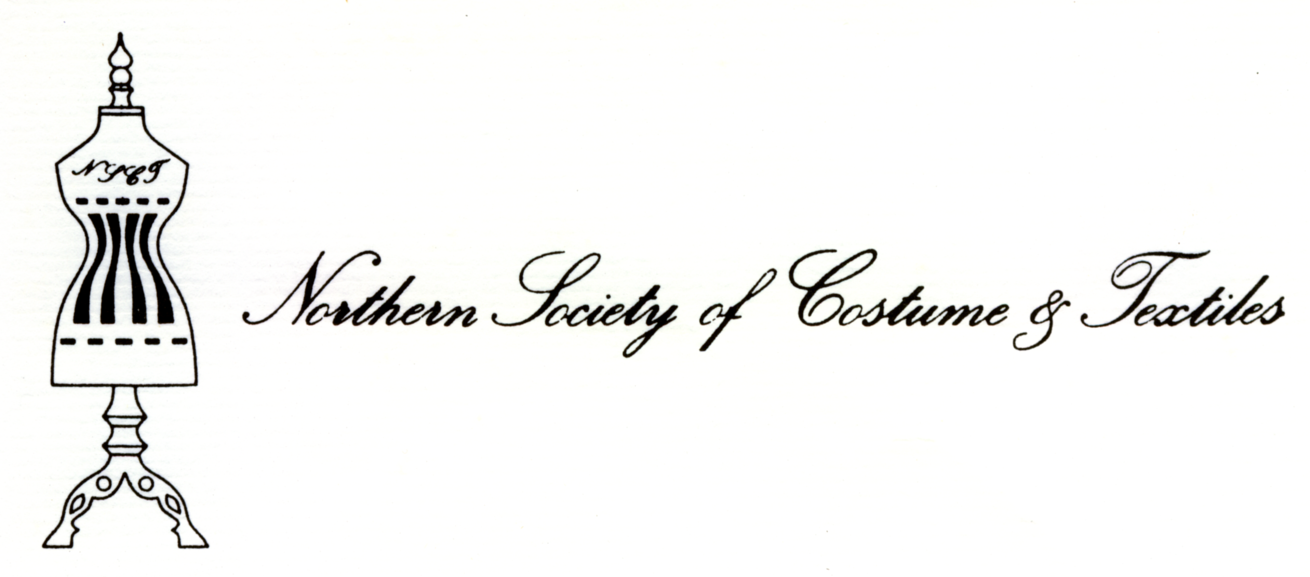

The Northern Society of Costume and Textiles is a Registered Charity

The Society, Registered Charity No. 513302, was founded in 1977. Although interested in all aspects of costume and textiles both ancient and modern, it does have a bias towards the historical and the wish to encourage the study and preservation of items from all ages and research into the history of their origins, make-up and use. The Society covers the whole of the north of England north from Nottingham and Derby to the Scottish border. Within this area, meetings are held in different venues four or five times a year, usually on Saturdays, and range from general visits to places of interest to detailed seminars on particular topics.

Members are drawn from all walks of life, some with considerable knowledge of costume and textiles, but many who are just enthusiasts keen to learn about the subject.

The current annual subscription rates are:

Ordinary membership £13.00
Student Membership (with proof of Student Status) £ 6.00
Institutional membership £20.00
Make cheques payable to the Northern Society of Costume and Textiles

The subscription year runs from 1st January each year, but members joining after 1st June are only required to pay half the subscription for that year.

Small charges are made to those attending each meeting to cover the costs of room hire, speaker’s fees, etc.

More details of the Society and its activities can be found on our website, www.nsct.org.uk

New members are always welcome. For more information contact
the Membership Secretary, (address on the right),
or the Honorary Secretary, Tel: 0113 318 8314

The Northern Society of Costume and Textiles is a Registered Charity No. 513302

APPLICATION FORM TO JOIN THE SOCIETY
Send to the Membership Secretary
www.nsct.org.uk Northern Society of Costume and Textiles
4 Almondroyd
Heckmondwike
West Yorkshire, WF16 9BP
e-mail: nstcmembership@hotmail.com

NAME (incl. Title) _________________________________________________________

ADDRESS _______________________________________________________________

_________________________________________________________________________

_________________________________________ Post Code ______________________

Telephone numbers: Home ____________________ Mobile _______________________

E-mail address _____________________________________________________________
(Supply of your e-mail address indicates that you are happy to receive information from the Society by this means.)

Occupation _______________________________________________________________

My main interests in costume and textiles are ____________________________________

_________________________________________________________________________

_________________________________________________________________________

I have particular knowledge in the following field(s) _______________________________

_________________________________________________________________________

_________________________________________________________________________

The information you supply above will be used in the planning of meetings and to keep you informed of the Society’s operations. We undertake to keep it all securely in accordance with the General Data Protection Regulations. We never share any of it with any other person or organisation. Past member’s data is not retained

Where did you hear about the Society __________________________________________

